1. Power BI Appears screenshot

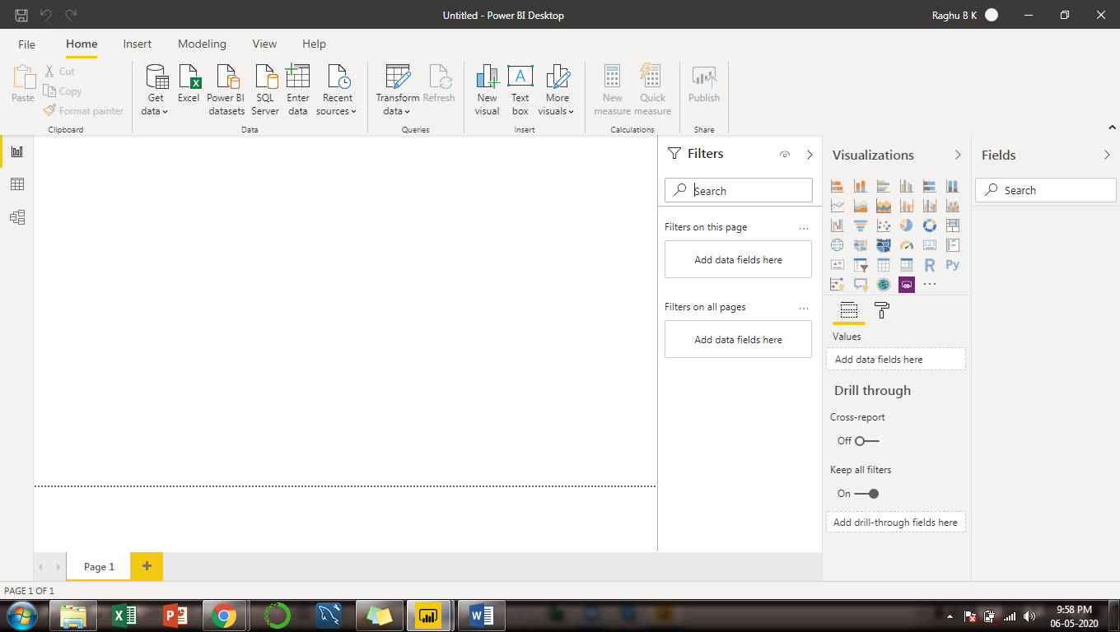

1. Report View screenshot

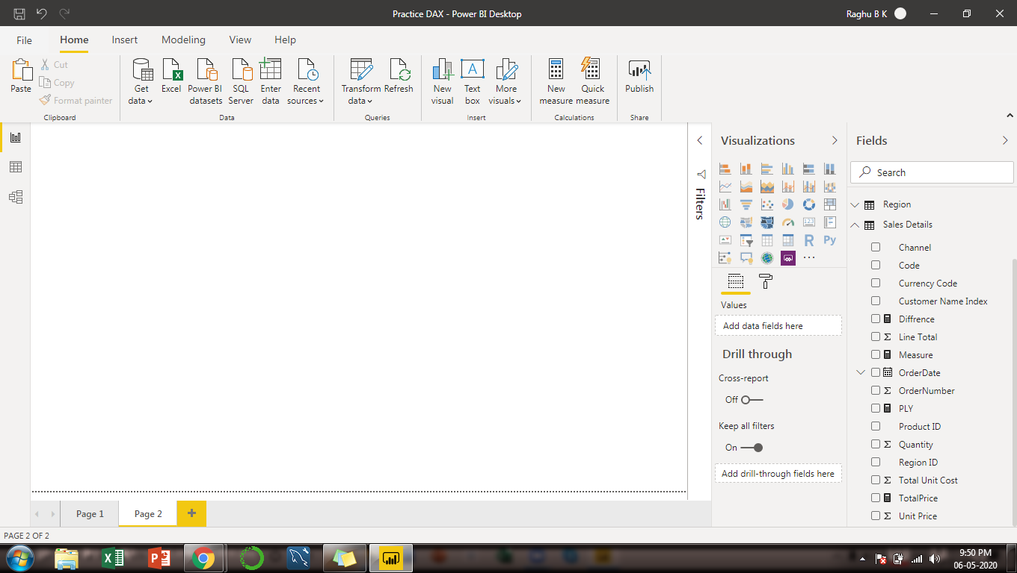

1. Data View

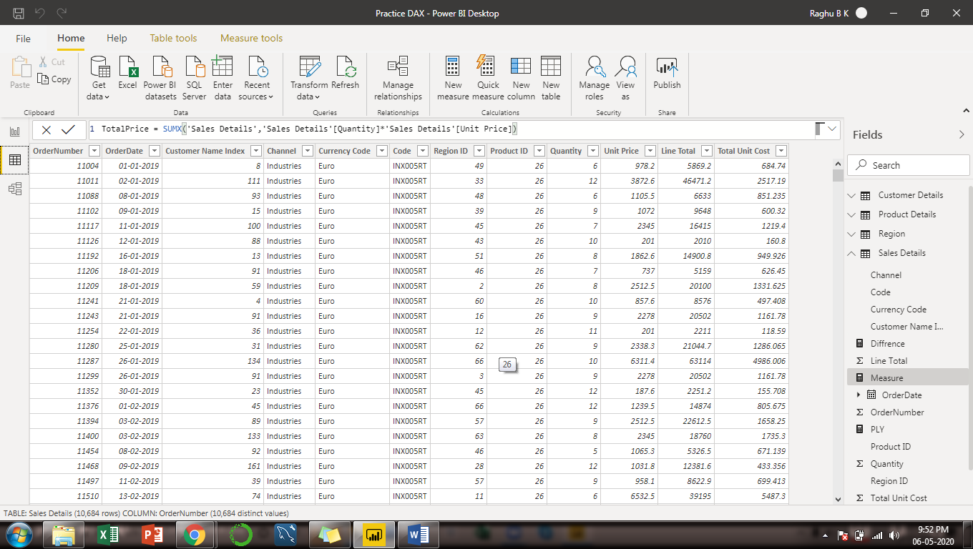

1. Model View

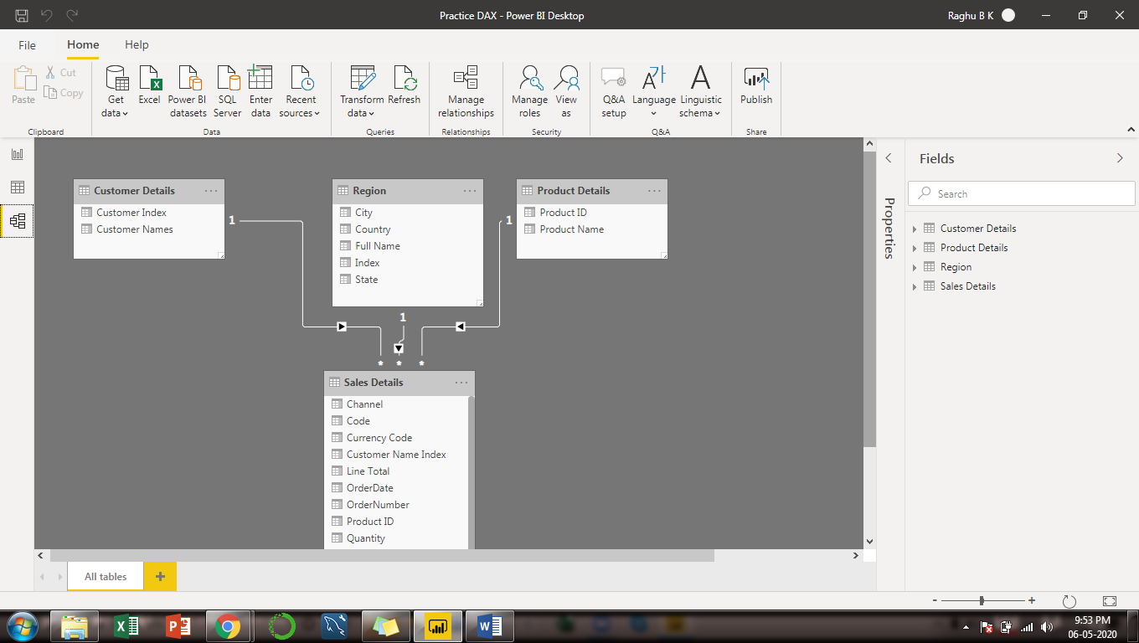

1. Power Query Editor

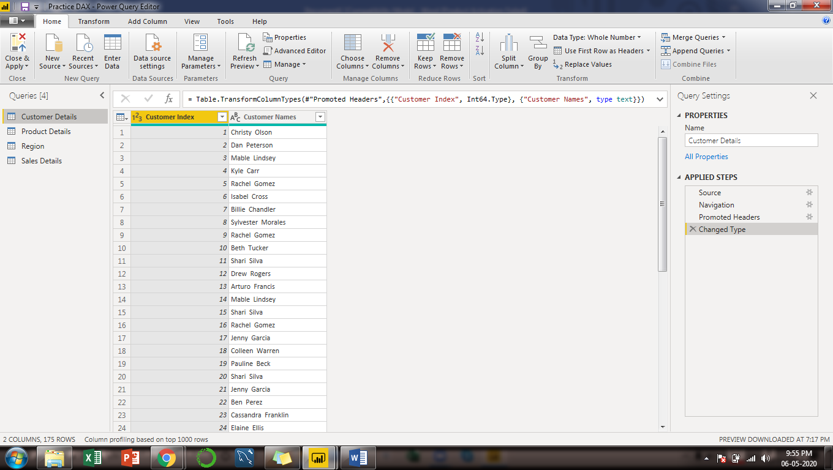

1. Advance Editor

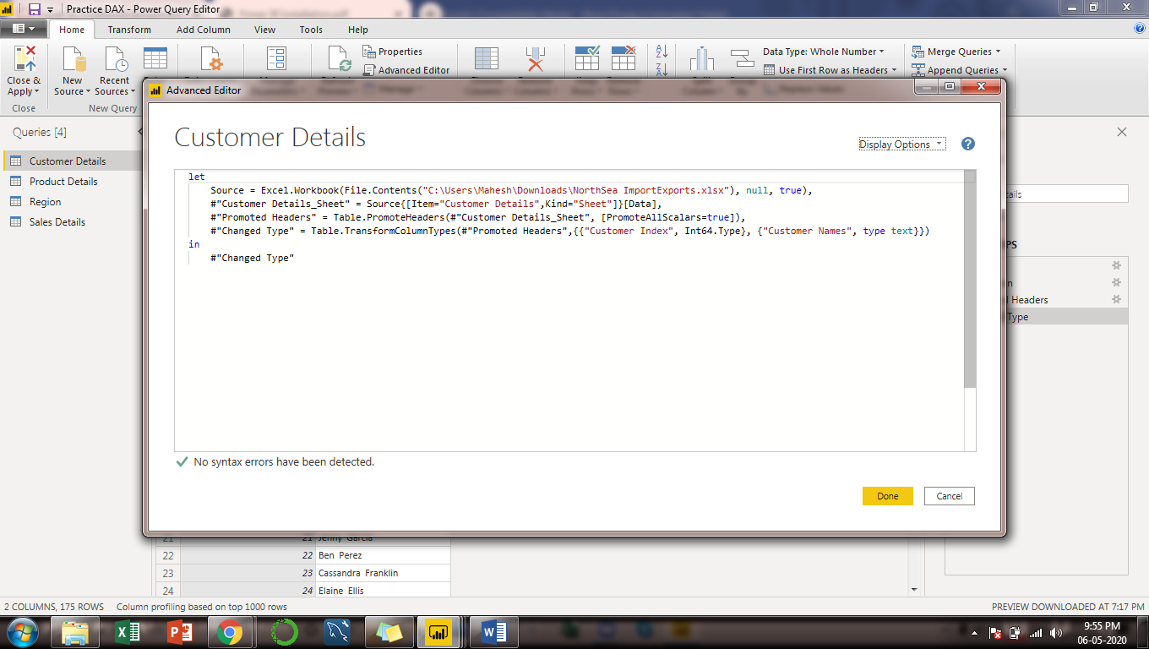

Price Details:-

Power BI Desktop : Free

Power BI Pro: $9.99/ per Month

Power BI Premium: $4995/ per month